Lab 03 - NAND Only Logic

In this lab, you’ve learned how to convert arbitrary logical equations into NAND only circuits, and why that might be a good thing.

# Rubric

| **Item** | **Description** | **Value** |
| --- | --- | --- |
| Summary Answers | Your writings about what you learned in this lab. | 25% |
| Question 1 | Your answers to the question | 25% |
| Question 2 | Your answers to the question | 25% |
| Question 3 | Your answers to the question | 25% |

# Lab Summary

Summarize your learnings from the lab here.

In this Lab we learned how to convert regular logic gates and equations to nand gates as well as how to breadboard with nand gates. We did this using DeMorgan’s law.

# Lab Questions

## 1 - Write down DeMorgan’s Law and the truth tables proving it out.

!(A and B) = !A or !B  
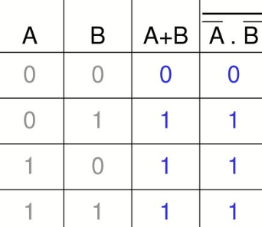

## 2 - What is the value in converting circuits to NAND only?

NAND only logic is not only more cost effective but is also compatible with any logic circuit.

## 3 - How does what you did in lab with the breadboard relate to the FPGA?

The breadboarding we did allowed us to create a custom FPGA with 4 NAND gates. This gives us custom output based on which switches are on or off.

# Code Submission

Upload a .zip of all your code or a public repository on GitHub.